EXPERIMENT-9
Name: Mithun Raj D Roll no:240701315

AIM:
The aim is to design input forms that validate data, such as email and phone number, and display error messages using HTML/CSS and JavaScript with Validator.js.

DESCRIPTION:
This experiment helps in understanding how client-side validation works and highlights the importance of preventing invalid data entry, thereby improving data accuracy and user experience in web applications.

Step 1:
Setting Up the HTML Form Start by creating an HTML form with input fields for the email and phone number
A contact form element is used to group all input fields together. Inside the form, two input fields are defined using the input tag:
- One for the email and name, where users enter their email address and name
- One for the phone number, where users enter their contact number
Each input field is labeled clearly so that the user understands what information is required. A submit button is also included to allow users to send their data for validation.

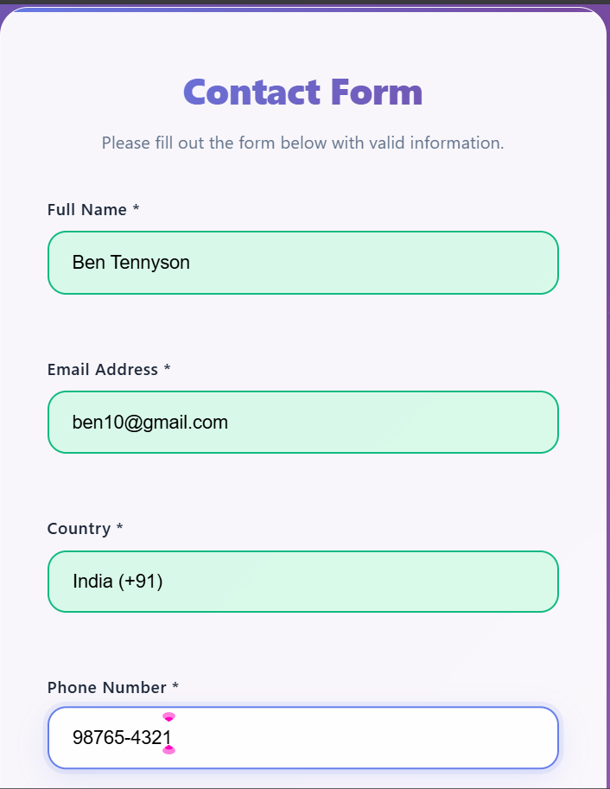

STEP-2:
Styling the Form with CSS Next, add some basic styling to make the form look nice.
In this step, CSS is used to improve the appearance of the HTML form and make it more visually appealing and user-friendly. Styling helps in organizing the layout, improving readability, and enhancing the overall user experience.
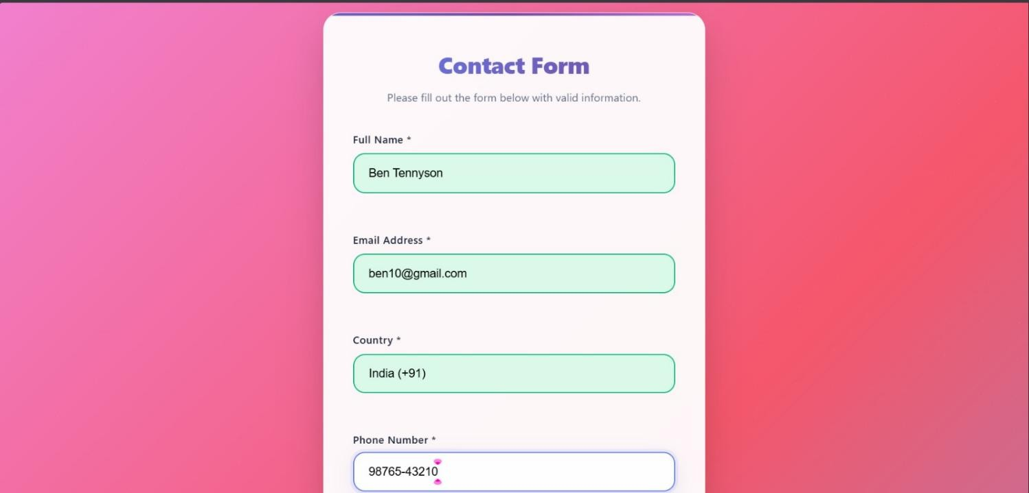

The input fields are styled to have proper width, spacing, and padding so that users can easily enter their data. The submit button is also designed with background color, text color, and hover effects to make it more noticeable and interactive.
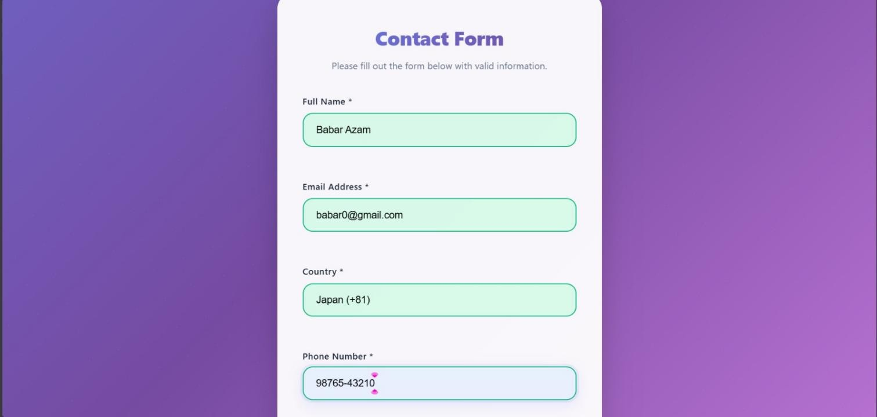
This new design includes:
- Animated gradient background with floating elements
- Glassmorphism card design with blur effects
- Enhanced form fields with modern styling
- Smooth animations and micro-interactions
- Better typography and spacing
- Ripple effects on buttons
- Shake animations for errors

Step 3: Adding JavaScript for Validation Finally
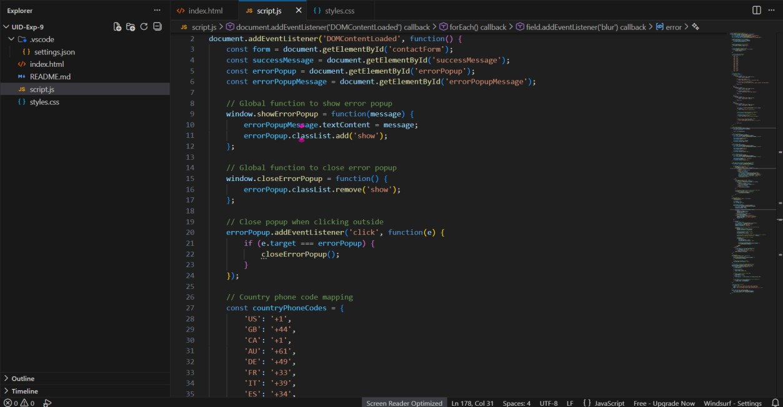
In this step, JavaScript is used to add validation logic to the form to ensure that the user enters correct and properly formatted data. The Validator.js library is included to simplify validation tasks such as checking email format and phone number validity.
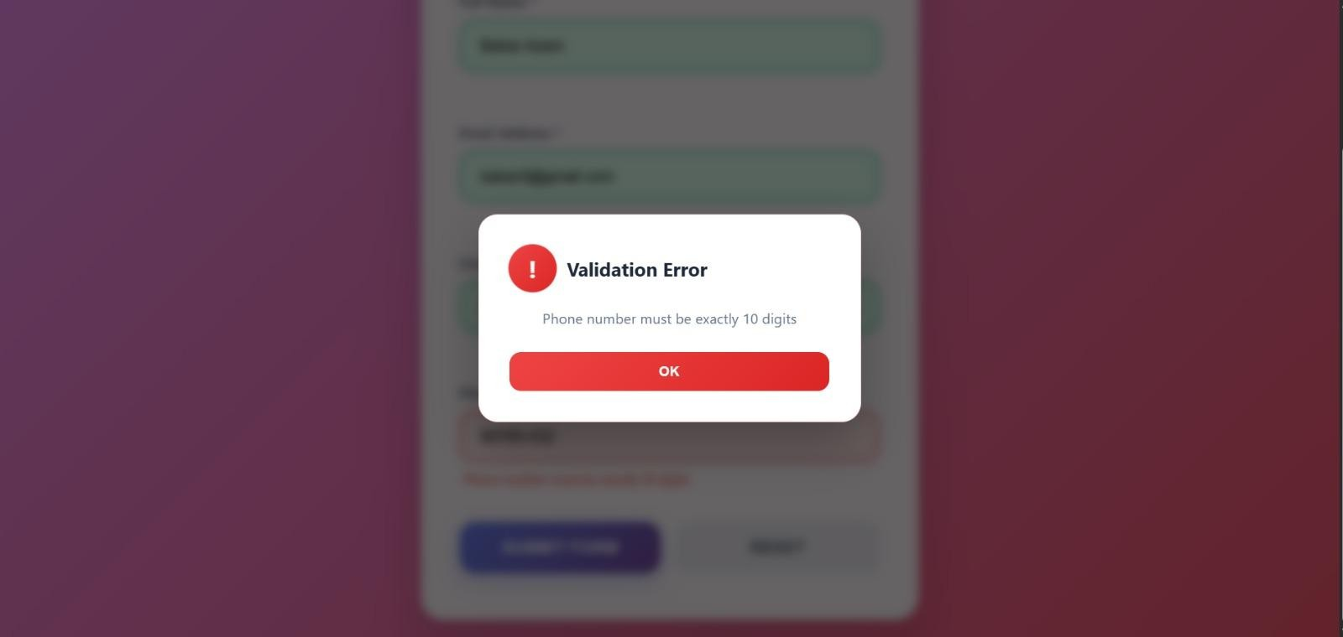
If any input is invalid, appropriate error messages are generated and displayed in the designated error message area.

This step ensures that incorrect or incomplete data is not submitted, thereby improving data accuracy, reliability, and user experience in the application.

